Practical 15: Personal Financial Planner

Aim

To prepare a personal financial planner using Excel.

Objectives
• To track expenses
• To compare budget vs actual

Materials Required
• Excel

Procedure
1. Enter expenses – Record all expense items with their categories, dates, and amounts in the spreadsheet.

2. Apply Data Validation – Set validation rules to restrict inputs, such as allowing only numbers or predefined categories.

3. Use SUMIF – Use the SUMIF function to total expenses by category or any specific condition you choose.

4. Create budget sheet – Design a separate sheet comparing planned budgets to actual spending for better tracking.

5. Highlight expenses above limit – Apply conditional formatting to automatically mark entries that exceed your budget limit.

6. Create charts – Generate charts to visually present spending patterns, category breakdowns, or monthly totals.

7. Adjust print settings – Modify page layout, scaling, and margins to ensure the sheet prints clearly and fits on the page.

A)Expenses:

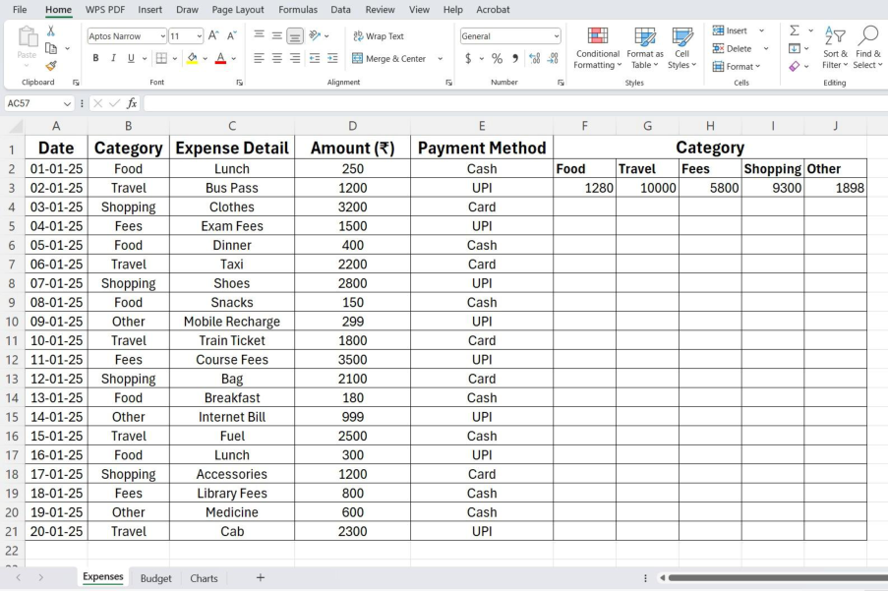

BUDGET :
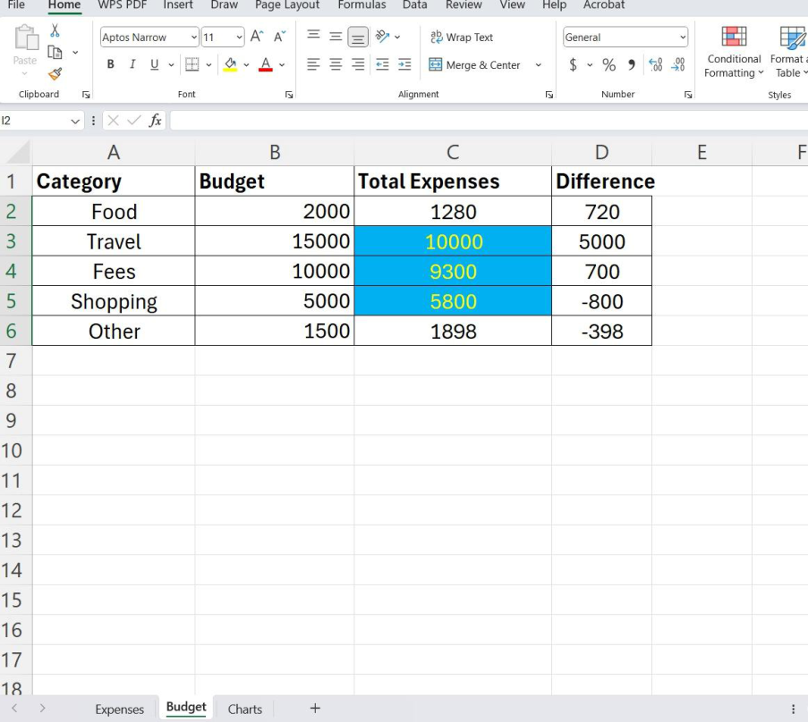

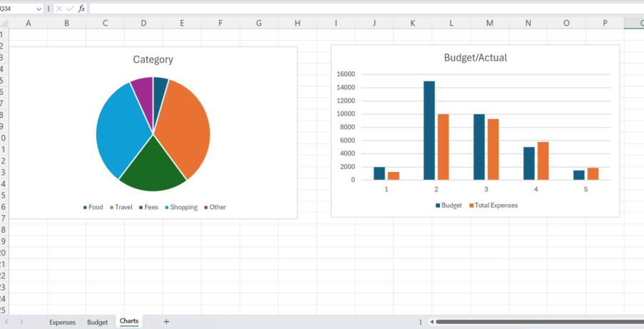
CHARTS :

